HOW TO TRANSFER FILES FROM PC TO SMARTPHONE AND FROM PC TO PC USING A WI-FI NETWORK SETUP BETWEEN THE TWO DEVICES

INTRODUCTION

A wireless ad hoc network (WANET) is a type of local area network (LAN) that is built spontaneously to enable two or more wireless devices to be connected to each other and share resources without requiring typical network infrastructure equipment such as a wireless router or access point.

Wi-Fi is a wireless networking technology that allows devices such as computers, mobile devices and other equipment to interface with the internet. It allows these devices and many more to exchange information with one another creating a network.

PART 1: TRANSFERRING FILES BETWEEN TWO PCs USING AN AD HOC NETWORK

1. I opened settings on PC01 and proceeded to network and internet and to change advanced sharing options where I turned ON network discovery and file and printer sharing options.

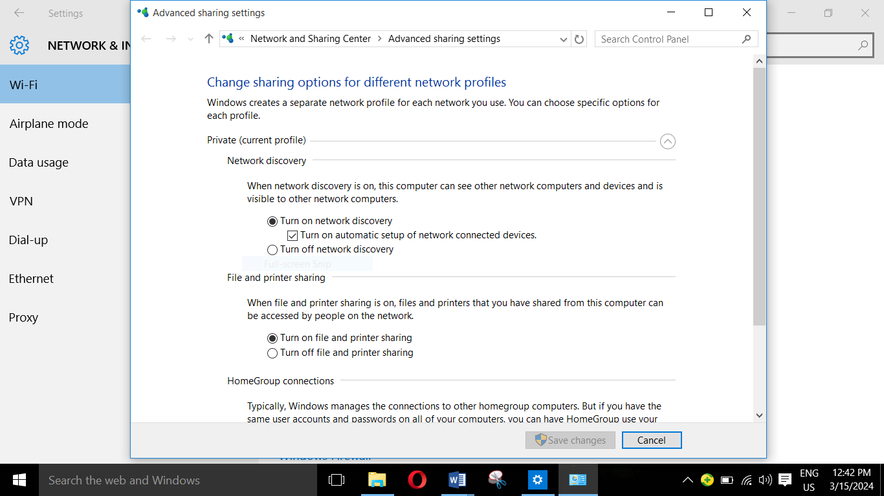

1. I opened command prompt were I typed the command to create an ad hoc network. In the first line of the command prompt, I typed the command line “netsh wlan set hostednetwork mode=allow ssid=GUY key=12345678” and pressed the enter key. In the second line, I typed the following command to initiate the start of the network “netsh wlan start hostednetwork and pressed the enter key which started the network.

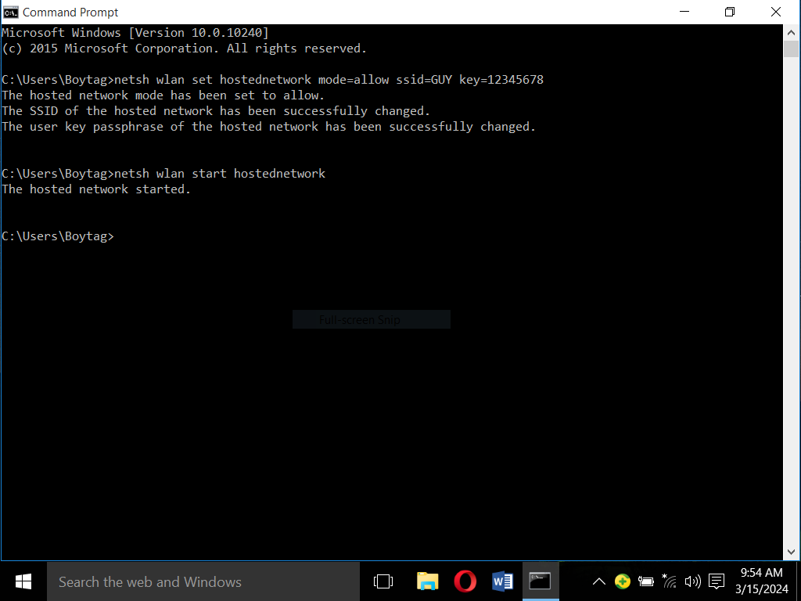

1. On PC02, I went to wifi centre, searched for available networks and connected to the network while providing the passkey I created on PC01. I also turned on network discovery and printer and file sharing on PC02 so that both of the computers could access each other.
2. I went to file manager where I selected network and both PCs where displayed.

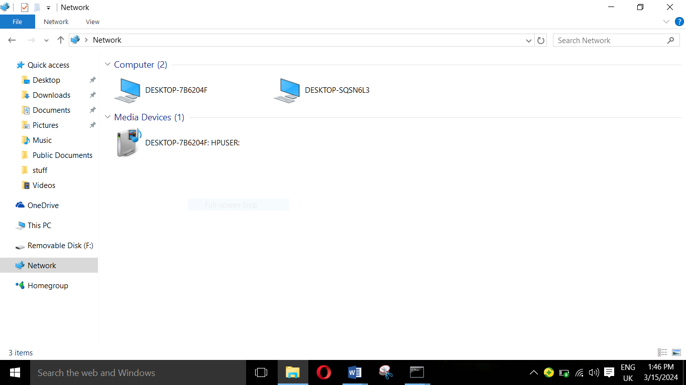

1. The two PCs were successfully connected and I was able to share a document between the two computers. I then returned to command prompt to stop the network which I used the following command line “netsh wlan stop hostednetwork”.

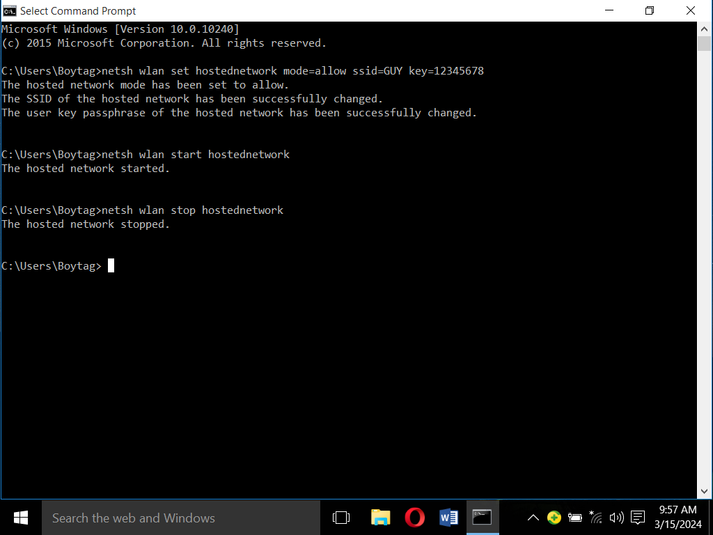

PART 2: CONNECTING A PC TO A SMARTPHONE USING WI-FI FOR FILE SHARING

1. I started by creating a hotspot on my phone by going to settings, network and internet, wifi and hotspot. I set the name of the hotspot, security type and password.

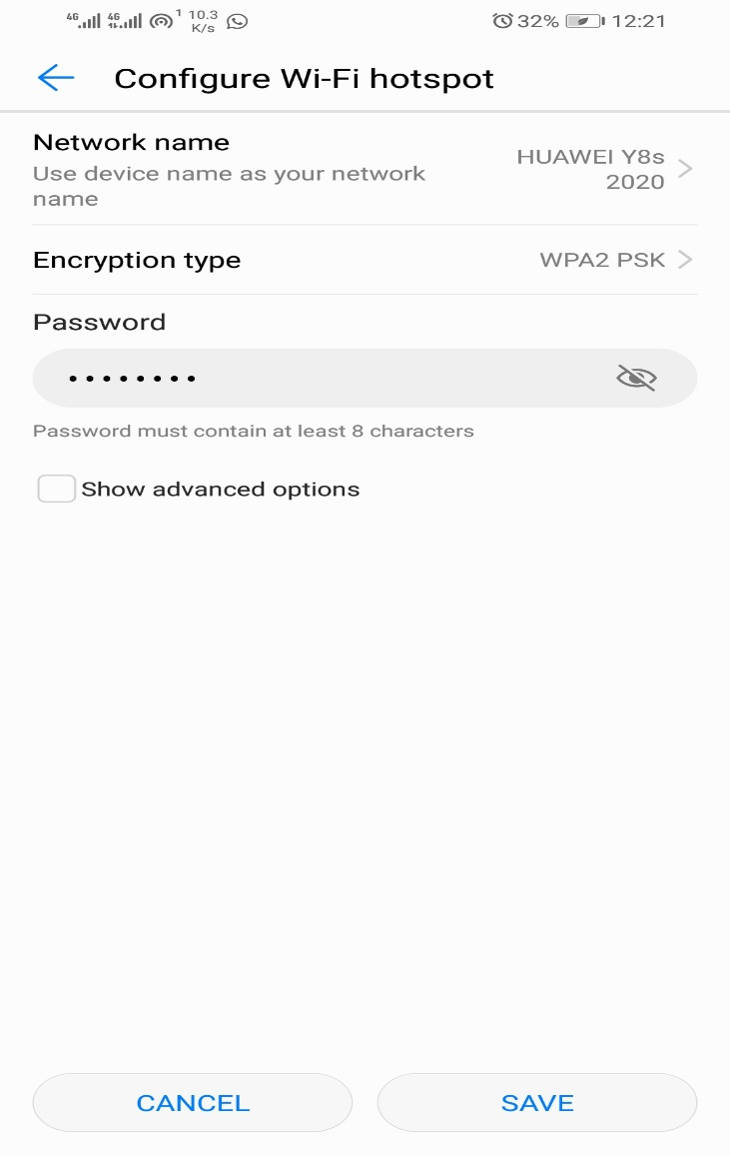

1. I then connected my PC to the wifi hotspot I created. When connecting, I was prompted to enter a password before I could connect to the hotspot.

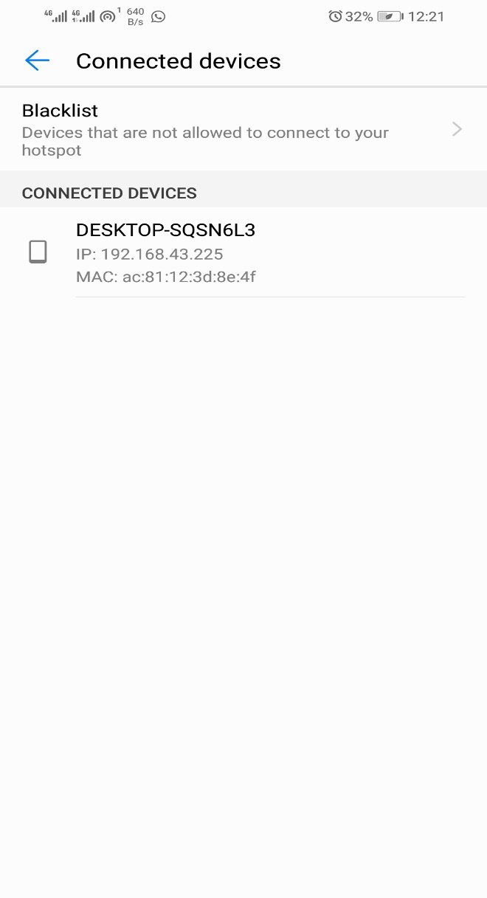

1. On my phone, I downloaded the Xender app from playstore and launched the app. I proceeded to the connection menu where I chose connect to PC.

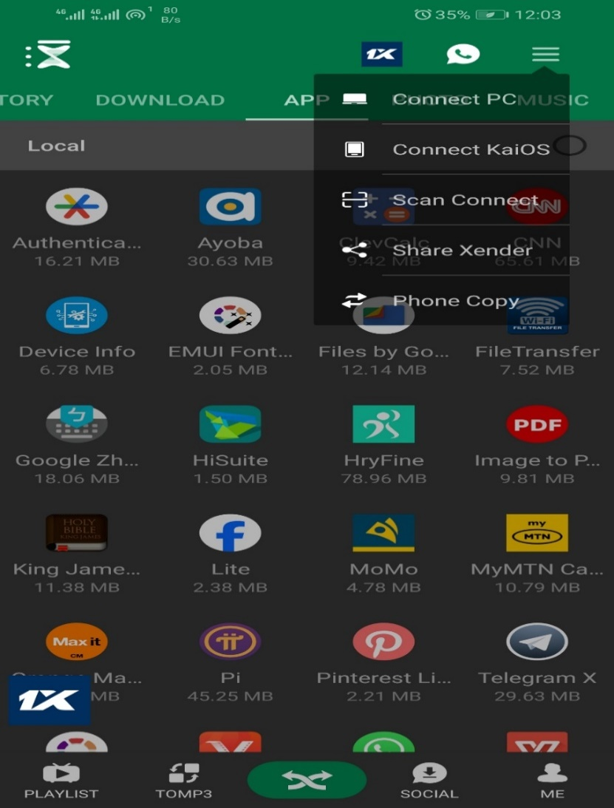

1. An IP address was displayed on the screen and a set of instructions were displayed on how to connect to the PC.

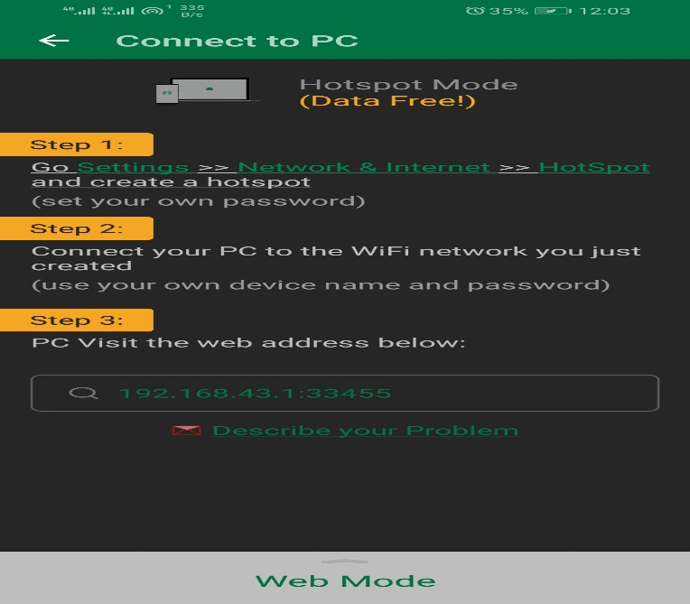

1. 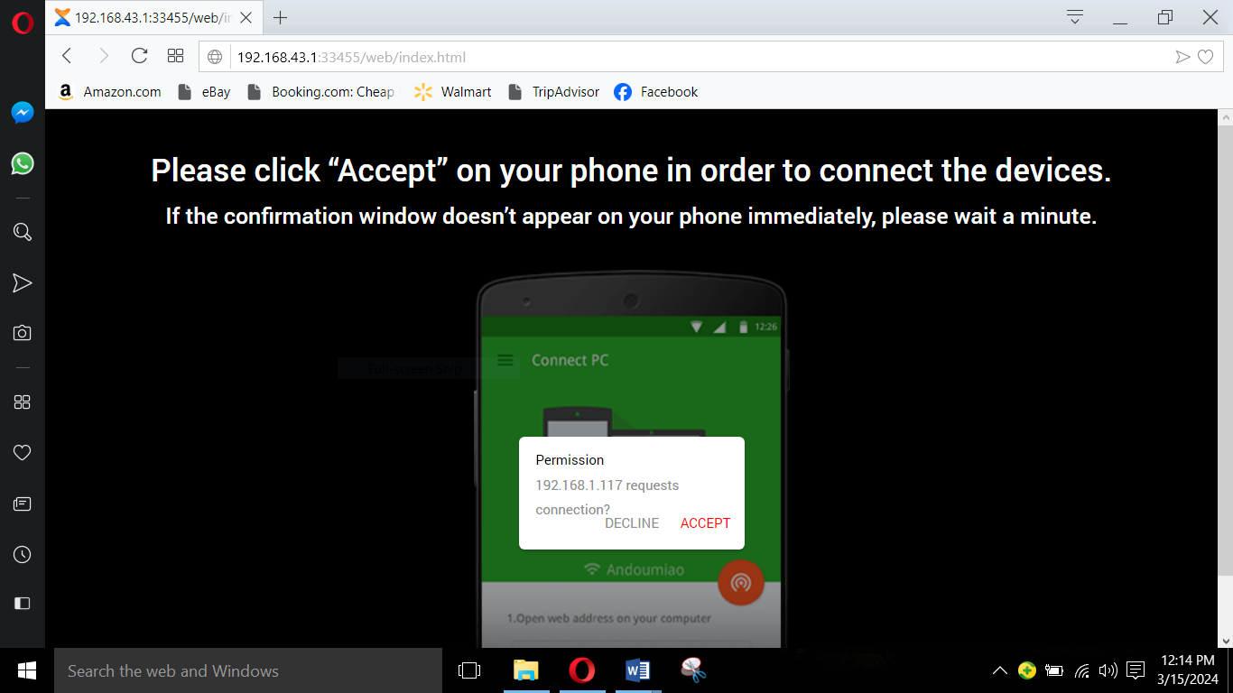I copied the IP address into a web browser which directed me to the xender webpage. I then got a prompt from my phone asking if to connect to the PC or to decline the request.
2. After accepting the request on my phone, the PC and the phone were connected and were able to share files.

